Name | Mobile: +65 1234 5678
Name | Email: abcd@outlook.com
Name | LinkedIn: https://www.linkedin.com/in/

Education
Singapore Institute of Technology - University of Glasgow | Sep 2023 –  Expected May 20xx
- Bachelor of Engineering with Honours in Mechanical Engineering (Specialization in XXX)
- Academic Excellence: Data Analytics | Sensors and Electronic System | Industrial Internet of Things

Singapore Polytechnic | Sep 2023 – 20XX
- Diploma in XXX
- Academic Excellence: Design and Build | Industrial Automation

work experience
Assistant Engineer (Full-time), DIGI Asia | Tokyo | Aug 2022 – Jun 2023
- Completed five single line diagrams of floor plans according to client specifications and conducted on-site visits with chief engineer to ensure workplace safety and achieved zero incidents
- Resolved on-site technical related issues and ensured the industrial project was implemented in accordance to approved design and completed on schedule
- Documented work processes to ensure project specifications met Quality Standards requirements

awards / achievements / CERTIFICATES
Design Challenge by Electrical Engineering Society - Merit Award May 2021
Class 3 Driving License, Singapore Valid May 2020
SOLIDWORKS Design Associate (CSWA) XXX 20XX
Lean Six Sigma Green Belt XXX 20XX
Certified PLC (Programmable Logic Controller) Programming Professional XXX 20XX

PROJECTS
1. Green House Climate Control | Aug 20XX
- Designed and developed an IoT-enabled electromechanical climate control system using the Arduino platform to automate greenhouse environmental regulation

Co-curricular Activities
President | Ngee Ann Polytechnic Stage Leo Club | Jun 2019 – Jun 2020
- Spearheaded community service projects such as food donation drives and elderly home visits along with a team of committee members which achieved a 100% signup rate among students

Skills / competencies
Programming Languages

- C++ (Advanced / Intermediate)
- Python (Advanced / Intermediate)
- MATLAB (Advanced / Intermediate)

Simulation and Modelling

- Simulink (Advanced / Intermediate)
- MATLAB Modelling and Simulation

Embedded Systems

- Simulink for embedded system development
- Basic microcontroller interfacing

Engineering and Design Software

- Navisworks (Advanced / Intermediate)
- CAD tools such as SolidWorks / Fusion 360

AI, Data and Digital Engineering

- Python (Pandas, NumPy) for engineering data analysis
- Power BI for engineering data visualization and dashboard development
- Applied regression and classification models in coursework/projects
- Exposure to predictive maintenance and fault detection concepts
- Sensor data analysis from engineering datasets

Additional Page
High impact keywords Mechanical Engineering fresh grads can include so their resumes:

AI and Machine Learning (Foundational / Applied Exposure)
• Applied Machine Learning (academic or project-based)
• Predictive Modelling (basic regression and classification models)
• Regression Analysis (linear and multiple regression)
• Classification Models (introductory level)
• Data Preprocessing (cleaning, transformation, feature scaling)
• Model Evaluation and Validation (train-test split, cross-validation basics)

Programming and Engineering Tools
• Python (engineering data analysis)
• MATLAB (simulation and numerical analysis)
• Scikit-learn (basic machine learning applications)
• Excel for Data Analysis

Engineering Data Applications
• Predictive Maintenance (project or academic simulations)
• Sensor Data Analysis (vibration, temperature, or experimental datasets)
• Fault Detection (rule-based or basic ML approaches)
• Time Series Analysis (trend and forecasting analysis)
• Data Visualization (plots, dashboards, engineering charts)

Digital Engineering and Industry 4.0 Exposure
• Smart Manufacturing (conceptual understanding and case studies)
• Industrial Automation (basic exposure to PLCs or automated systems)
• Digital Twin (conceptual familiarity or introductory exposure)
• Data-driven Engineering Optimisation

Engineering Decision Support and Workflow
• Engineering Data Analysis and Interpretation
• Data-driven Decision Making (project-based application)
• Use of AI-assisted Tools for Coding and Analysis (e.g., ChatGPT, Copilot)

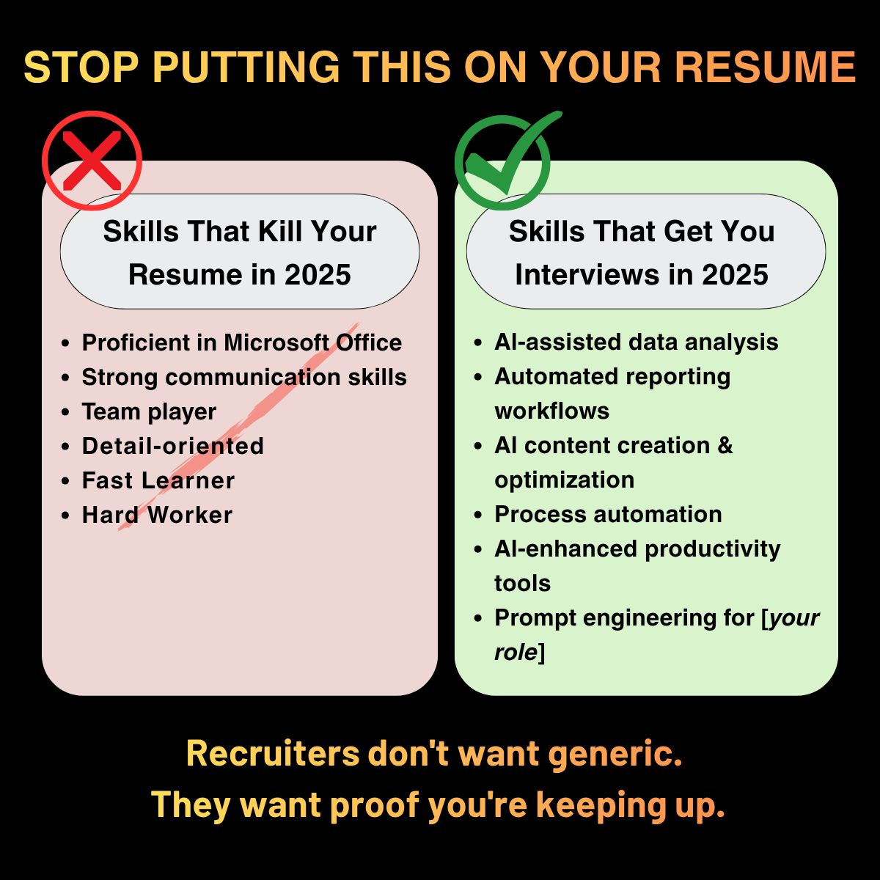

AI 3D Portolio websites to explore sharing your projects and results achieved:
Https://loveable.dev - https://joeydanna.com/cad-portfolio/ (Examples)
Https://spline.design

